**Sales Report Document**

This report will drive us to understand the amount spent on each product by the customer and the total number of transactions, it gives us insights into the most purchased product by individual customers based on country, minimum transaction based on sales amount, and the pending delivery status of the product.

**Data Source:**

Customer: Gives information on Customer, Country, and Age details.

Order: Gives information on Products and Amount of each product.

Shipping: Gives information on Product status whether Delivered or Pending.

**Data Definition:**

Info Cards:

Total Sales: Total Sales Amount in the source.

Number of Products: Total number of distinct products available in the source.

Slicers:

Age Category: To select the Customer whose Age is less than 30 or greater than 30 years.

Customer: To view the sales insights based on individual customers or set of customers.

Country: To view the sales insights based on Country.

Visualizations:

Total Sales by Country and by Products: Gives information on the total sales amount contributed by individual country and the total number of products sold in each country.

Most Purchased Product: Gives information on the total number of products sold.

Pending Status by Country: Gives clear insights into the pending products yet to be delivered for each country.

Amount Spent by Customer on Products: Gives information on the amount spent by individual customers on each product.

County Sales by Min Transaction: Gives information on the country that has made the minimum transactions on the products and by sales amount.

**Requirements and the solutions:**

1. *the total amount spent and the country for the Pending delivery status for each country.*

The total sales amount is 532500 and the pending delivery status for each country is shown below.

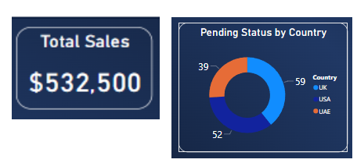

1. *the total number of transactions, total quantity sold, and total amount spent for each customer, along with the product details.*

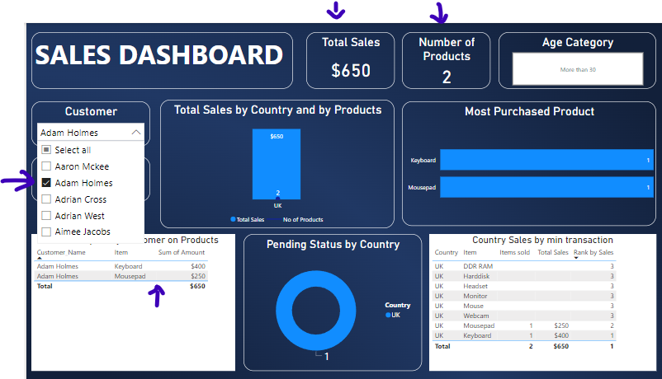

By selecting a customer name from the customer slicer, the end user will be able to view complete information on the transactions.

For example, consider Adam Holmes, who has ordered 2 products (Keyboard and Mousepad), the total amount spent on those products (400,250 respectively) is $650 and his age comes under the more than 30 years category.

1. *the maximum product purchased for each country.*

The first graph gives us information on the total number of products or the maximum number of products purchased for each country. The second graph gives us insights into individual products sold for each country.

End users can also try to select the country slicers to view individual records.

1. *the most purchased product based on the age category of less than 30 and above 30.*

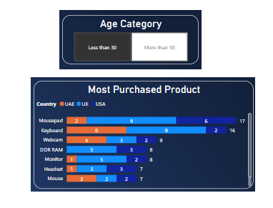

End users can switch between the Age category of less than 30 and more than 30. If less than 30 is selected then, the Most purchased Product graph will be filtered accordingly and displays the most purchased product at the top. Here Mousepad is the most purchased product under less than 30 age categories.

1. *the country that had minimum transactions and sales amount.*

This graph shows clearly about the minimum transaction or minimum sales amount contributed by country.

Here UAE had made less contribution in purchasing Mouse for $900 which is the least among all.